Sample File for Physics Reports of Kumamoto University

Taro Yamada1, Hanako Suzuki1 and Jiro Kobayashi2
1Department of Physics, Kyushu University, Fukuoka 810-8560
2Department of Physics, Kumamoto University, Kumamoto 860-8555

(Received November 30, 2012)

Simulations of supernova remnant Cas A are performed starting from the supernova explosion to the present phase of the remnant. Before the explosion, distributions of circum- stellar medium is constructed, where the medium is assumed to be ejected from a progenitor star. A supernova simulation is carried out by two dimensional hydrodynamical calculation. While Rayleigh-Taylor instability is advanced from the boundary between hydrogen (H) and helium (He) layers, that from silicon (Si) and iron (Fe) layers is not grown enough to explain the observations. It is suggested that mixing before the explosion and/or instability at the boundary for Si and Fe due to diﬀerent distributions of circumstellar medium is needed to explain the observations.

§1. Introduction

Supernova remnant Cassiopeia A (Cas A) is the youngest in our Galaxy. Cas A is the brightest radio source so far.1) Moreover, it has been observed in possible bands of the spectrum: radio,2), 3) infrared,4), 5) visible6), 7) and X-ray.8), 9) Therefore, Cas A becomes one of the main targets for numerical simulations of supernova explosions.
Supernova remnant Cassiopeia A (Cas A) is the youngest in our Galaxy. Cas A is the brightest radio source so far.1) Moreover, it has been observed in possible bands of the spectrum: radio,2), 3) infrared,4), 5) visible6), 7) and X-ray.8), 9) Therefore, Cas A becomes one of the main targets for numerical simulations of supernova explosions.
Supernova remnant Cassiopeia A (Cas A) is the youngest in our Galaxy. Cas A is the brightest radio source so far.1) Moreover, it has been observed in possible bands of the spectrum: radio,2), 3) infrared,4), 5) visible6), 7) and X-ray.8), 9) Therefore, Cas A becomes one of the main targets for numerical simulations of supernova explosions.

§2. Basic equations

Let D/Dt be the Lagrange diﬀerentiation, which varies along the ﬂuid particle. The non-relativistic equations of ﬂuid dynamics relevant for the simulations are
∇²Φ= 4πGρ (2.1)
where ρ and Φ are the density and velocity, respectively, of ﬂuid. Mpt is the mass of the point source at the center. Self gravitational potential Φ is obtained by solving the following Poisson equation
∇²Φ= 4πGρ. (2.2)
Let D/Dt be the Lagrange diﬀerentiation, which varies along the ﬂuid particle. The non-relativistic equations of ﬂuid dynamics relevant for the simulations are
∇²Φ= 4πGρ (2.3)
where ρ and Φ are the density and velocity, respectively, of ﬂuid. Mpt is the mass of the point source at the center. Self gravitational potential Φ is obtained by solving the following Poisson equation
∇²Φ= 4πGρ. (2.4)

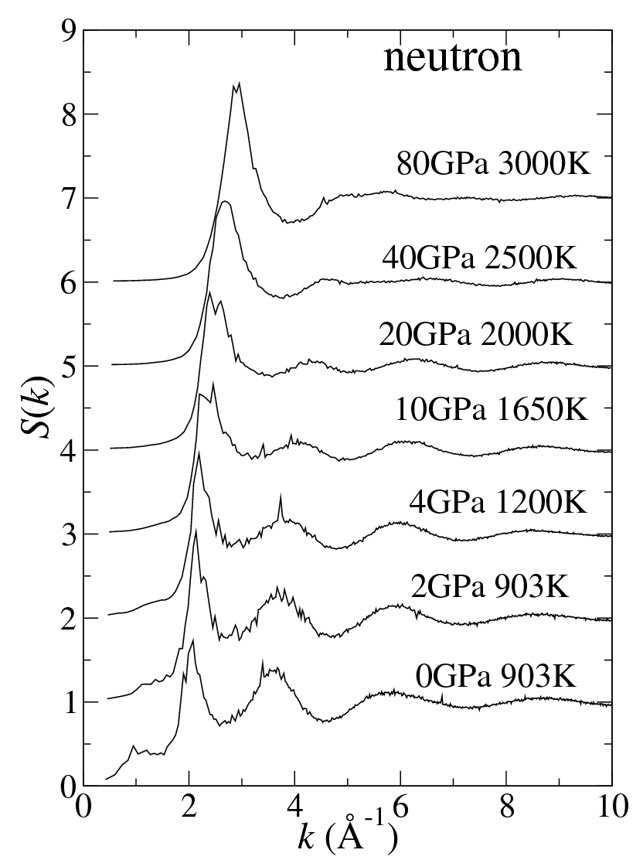
Fig. 1. Evolution of WR wind and RSG wind. Wind shells are formed at the boundary between the two winds.

§3. Initial Models

3.1. Construction of the circumstellar medium
Observations indicate that before the explosion, a progenitor star had lost the most hydrogen-rich envelope.14) We may infer that the progenitor of Cas A was a Wolf-Rayet star: the progenitor experiences three stellar evolutionary stages from the main sequence stage (MS) to red super giant stage (RSG) and ﬁnally Wolf-Rayet stage.
According to the previous evolution calculations, RSG continues ∼ 0.6 Myr and the typical wind velocity is ∼ 10 km s−1.19) As the result, the boundary between MS wind and RSG wind locates ≈ 6 pc which is much further compared to the forward shock front of 2.5 ± 0.2 pc.21) Therefore, we neglect the eﬀects of the MS wind.
According to the previous evolution calculations, RSG continues ∼ 0.6 Myr and the typical wind velocity is ∼ 10 km s−1.19) As the result, the boundary between MS wind and RSG wind locates ≈ 6 pc which is much further compared to the forward shock front of 2.5 ± 0.2 pc.21) Therefore, we neglect the eﬀects of the MS wind.
3.2. Observational constraints due to one dimensional simulations
We use the presupernova model of 6M⊙ He-core and initial models are con- structed by connection this presupernova model and the results of wind evolution shown in subsection 3.1. In Fig. 2, left and right panels show the initial density of the case of 0 yr and that of 2000 yr for TWR , respectively. From the observations of Cas A, location of the forward shock (Rfs) is 2.5 ± 0.2 pc.21) On the other hand, the reverse shock (Rrs ) locates at 1.6 ± 0.2 pc.21) As shown in Table I, only a model WR0E4 can explain the observations of both Rfs and Rrs , which is consistent with the previous study.27) As a consequence, we examine the matter mixing due to the Rayleigh-Taylor instabilities using only the model WR0E4.

§4. Two dimensional hydrodynamical simulations and Rayleigh-Taylor instabilities

We have performed two dimensional simulations with use of the initial model WR0E4. The simulation regions are divided by 1000 in the direction of r and 100 in that of θ.28) We give, purturbations in r-components of velocities when the shock wave passed the boundary at t = 3.9 s between carbon-oxygen and helium-rich layers, which cover the region between oxygen rich and helium rich layers:
δvr = ϵvr cos(20θ), (4.1)
where we set ϵ = 0.1. The region of the Rayleigh-Taylor instabilities can be found from the condition:29)
∇ρ·∇P < 0. (4.2)
This condition is satisﬁed for most regions of the boundary layers after the shock propagation.
During the propagation of the shock wave, we follow the abundance change using the α network code which include 13 nuclei of 4He, 12 C, 16 O, 20Ne, 24Mg, 28Si , 32 S, 36Ar, 40 Ca, 44 Ti, 48 Cr, 52 Fe, and 56Ni.30) Furthermore, to get the produced radio active nuclei of 44 Ti and 56 Ni detailed nucleosynthesis calculations are performed for the necessary ﬂuid particles by using the post process method with the network of 464 nuclei.31)
Results of the simulations at t = 1010 s (330 yr) after the explosion are shown in Fig. 2. The density contours are seen in the left panel, where the instabilities are developed for the regions of r > 1018 cm and 5 1018 cm. The former region is attributed to the boundary between original O- and Si-rich layers. The latter corresponds to the boundary between original H- and He-rich layers. We note that in the deep layer of O-rich layer, both Si and Fe are produced due to the explosive oxygen burning, where most Fe are produced as the daughter of radioactive nuclei 56Ni. As shown in right panel, any mixing between the abundances of Si and Fe does not appear in the whole simulations.

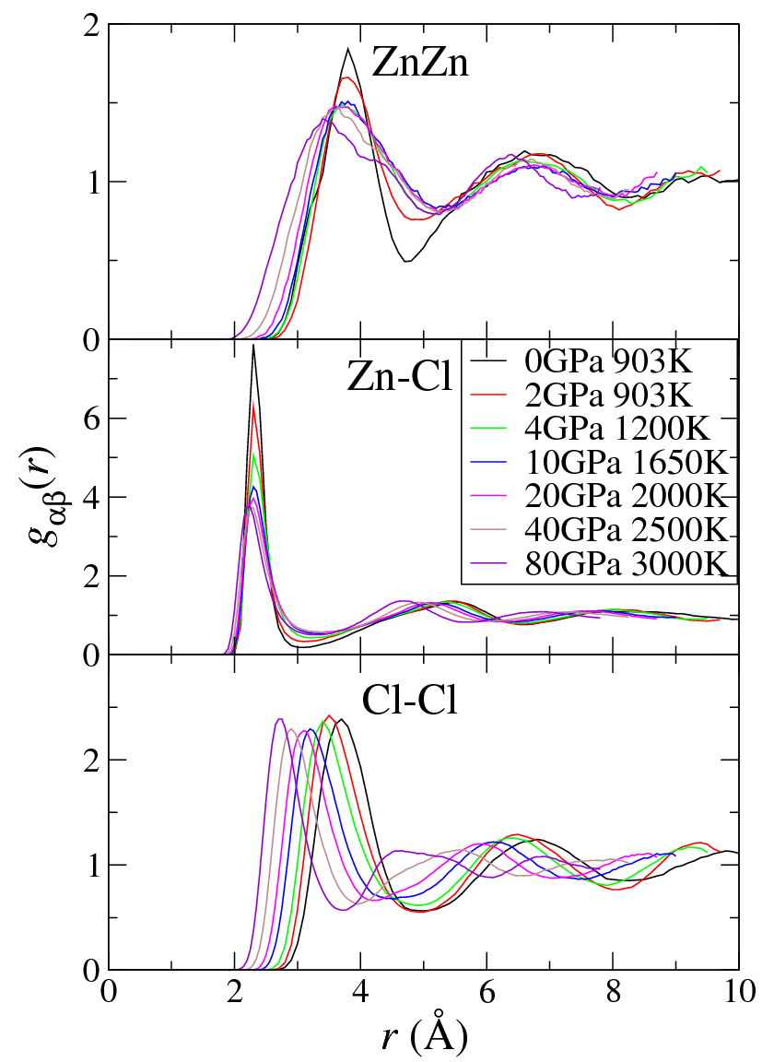
Fig. 2. Contours of the logarithm of density [gcm−3 ] (left panel) and the distribution of main abundances (right) at t = 330 yr measured from the explosion. The dashed region of Si includes O, where mass fraction of Si is larger than 5 % of that of O. The region of He and O are almost occupied by those elements.

§5. Concluding remarks

In the present study, we cannot ﬁnd regions where the mixing between Si and Fe abundances occurs due to the Rayleigh-Taylor instability. However, after the shock passage the regions having a lot of Si and/or Fe abundances are always unstable considering the instability condition (4.2). We would suggest the possible solution for the mixing to realize.
1) Resolution of the calculations should be reﬁned. We have divided the cal- culation region by 1000 (r) × 100 (θ). It is diﬃcult to follow both the shock wave outside the star and the Fe layers conﬁned deep inside the star. Kifonidis simulated core collapse supernova with higher resolution by using adaptive mesh reﬁnement (AMR).34) Their results may imply that our calculation is not enough to resolve the instabilities for the matter mixing.
2) Another initial models should be checked. As seen in Fig. 3, Si layers extends only to ∼ 2 pc, which is inconsistent with the observations. This is related to the distributions of the circumstellar medium. Fig. 4 shows time variations of the forward shock, the reverse shock and the surface of the distribution of the Fe for the case of TWR = 0 yr (left panel) and TWR = 2000 yr (right panel). It is clear that the model of TWR = 0 yr diﬀers from that of TWR = 2000 yr for the way of shock propagation.
3) Another initial models should be checked. As seen in Fig. 3, Si layers extends only to ∼ 2 pc, which is inconsistent with the observations. This is related to the distributions of the circumstellar medium. Fig. 4 shows time variations of the forward shock, the reverse shock and the surface of the distribution of the Fe for the case of TWR = 0 yr (left panel) and TWR = 2000 yr (right panel). It is clear that the model of TWR = 0 yr diﬀers from that of TWR = 2000 yr for the way of shock propagation.

Acknowledgments

This work has been supported in part by a Grant-in-Aid for Scientiﬁc Research (19104006, 21540272) of the Ministry of Education, Culture, Sports, Science and Technology of Japan.

References
- M. Ryle and G. Smith, Nature 162 (1948), 462.
- M. Anerson, L. Rudnick, P. Lippik, R. Perley, and R. Braun, Astrophys. J. 373 (1991), 146.
- J. W. Keohane, L. Rudnick and M. C. Anderson, Astrophys. J. 466 (1996), 1309.
- O. Krause et al. Science 308 (2005), 604.
- J. A. Ennis, L. Rudnick, W. T. Reach, J. D. Smith, J. Rho, T. Delaney, H. Gomez and T. Kozawa, Astrophys. J. 652 (2006), 376.
- R. A. Fesen and K. S. Gunderson, Astrophys. J. 652 (1996), 376.
- J. A. Morse, R. A. Fesen, R. A. Chevalier, K. J. Borkowski, C. L. Gerardy, S. S. Lawrence and S. van den Bergh, Astrophys. J. 614 (2004), 727.
- R. Willingele, J. A. Bleeker, K. J. van der Heyden and J. S. Kaastra, A&A 398 (2003), 1021.

