**Graphene Oxide and Reduced Graphene Oxide Hybrids

Shinya Hayami, Asami Funatsu, Yasumichi Matsumoto

Graduate School of Science and Technology, Kumamoto University

2-39-1 Kurokami, Chuo-ku, Kumamoto, 860-8555, Japan.

(e-mail: hayami@sci.kumamoto-u.ac.jp)

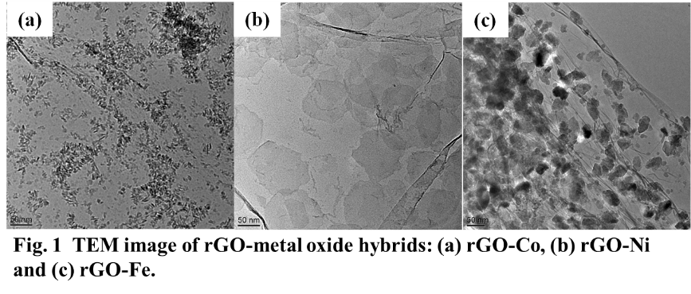Magnetic property based on inorganic molecule and electronic conductivity originating from delocalized electron in organic materials can be unified through formation of organic-inorganic assembly, a common phenomenon for devising multifunctional hybrids with numerous fascinating applications. These heterogeneous materials can be assembled by layering the organic and inorganic components alternately and the resultant hybrids exist like nano-composites with persistent individual properties. Graphene oxide (GO) is intermediate in the process making graphene, GO can be synthesized by slight modification to Hummers method. The reduction product (rGO) is falsely similar to the graphene. GO is single discrete sheets, and can be considered as oxidized form of graphene containing various carbonaceous functional groups. The polar oxygen atoms show strong affinity for incoming a variety of cations even proton. The negative GO nanosheets show strong electrostatic attraction toward positively charged metal ions to form GO-metal complexes. These complexes undergo reduction accompanied by shifting of some oxygen atom from GO precursor to metal ions and rGO-metal oxide hybrid is formed finally. Furthermore, GO has many epoxy group (C-O-C), the groups can make a bond with amine groups. Therefore, a various of GO hybrids, not only GO-metal hybrids but also GO-organic, metal complex and so on hybrids, can be produced. After reduction of GO hybrids, rGO-hybrids also can be produced. We have aimed at developing multi functional materials syncronizing both GO / rGO and metal complex properties.